**Types of ISP Connections**

Single Homed site

Not recommended to use BGP.

* Single homed site has only one exit path to the ISP
* In this type of site, you can use static routes, or advertise the site routes to the ISP and receive a default route from the ISP.

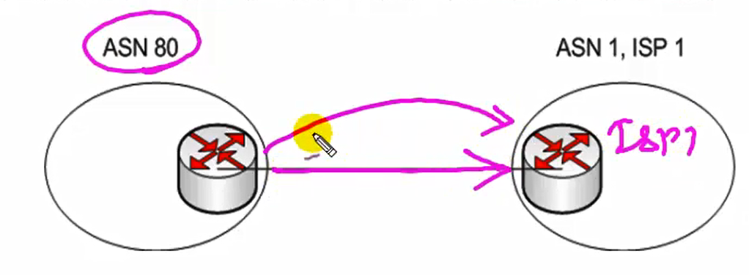

Dual-homed site

Not recommended to use BGP.

|  |  |
| --- | --- |
| * This site has two connections to the same ISP, either from one or two routers * One link might be the primary link and the other a backup or the site might load balance over both links. * Static or dynamic router would work in this case. |  |

Multihoming

recommended to use BGP.

|  |  |
| --- | --- |
| * When you got two exit paths from the same ASN. * This is used for redundancy and backup if one ISP fails and for better performance if one ISP provides a better path to frequently used networks. |  |

Dual Multihomed

recommended to use BGP.

|  |  |
| --- | --- |
| * It takes multi-homed further with two connections to each ISPs. * This gives the most redundancy. * BGP is used with the ISPs and can be used internally as well. |  |

**Connecting to the internet with BGP**

**How are we going to exchange the routes?**

**There are three different methods of exchange routes with the ISP.**

1. Default route from provider(s)

Easy on resources but does not allow any path manipulation.

1. Some specific routes + default router

This allows path manipulation with specific routes received from the ISP.

1. All routes (full table)

Hard on resources but guarantees the most direct path is taken.